SUCCESS STORY FOR THE YEAR 2015-16

Name of the farmer – Sardaru Ram S/o Sh. Hirdu Ram
Village Sughar, P.O. Tea Estate Bandla
Tehsil Palampur, Distt. Kangra
Himachal Pradesh

Sh. Sardaru Ram is a traditional goat rearer belonging to Gaddi community of Kangra District of the state. He is involved in this occupation for last 10-15 years. He had a flock size of 70 goats at the time of inclusion in the project. During survey while interacting with the project staff the farmer had opined that goat rearing in the state is becoming difficult for traditional goat rearers mainly due to decrease in pasture areas, increase in wild animal attacks, theft during migration, disease losses and decline in profitability productivity. Further there is lack of institutional and Government support especially for better breeding efficiency.
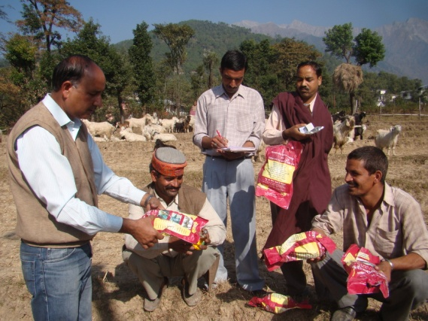
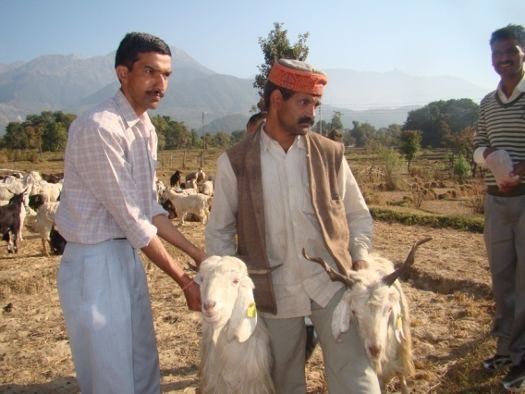

Sh Sardaru Ram was explained the mandates of the project and he gladly agreed to be included in project as one of the field units. After managemental intervention in feeding (feed and mineral mixtures), health (vaccination and routine health check up during migration) and breeding (superior buck) for two year after initial implementation of the project, there is increase in productivity as reflected by gradual increase in various growth traits and reduction in mortality especially pre weaning, which eventually resulted increase in profitability as comparatively higher young ones reached marketable age and flock size increased from 70 to 110. An increase in kid survival rate due to decrease in pre weaning and post weaning mortality is being observed which in turn has led to profitability and net income through selling of surplus stock. The farmer is earning approximately Rs. Four lakh per year through selling of surplus stock (approximately Rs. 6500 to 7000 per pair of kid). The farmer is now taking keen interest in his goat farming activities and is quite satisfied with the progress of his flock.

